Testing question | Yes/No | Notes / Evidence
Does the prototype open or start correctly? | Yes | 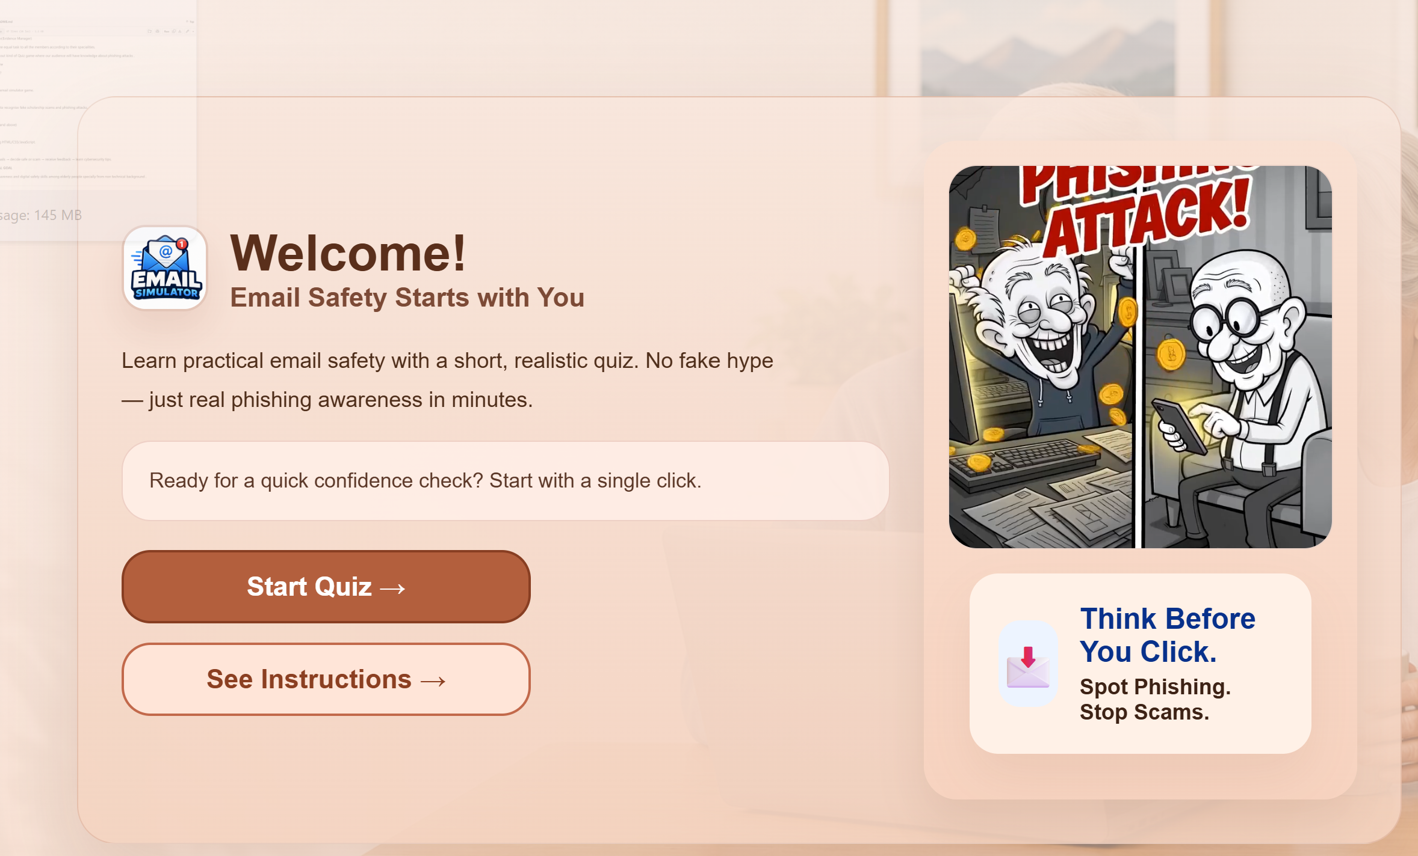
Is the welcome/title screen clear? | Yes | 
Are the instructions easy to understand? | Yes | 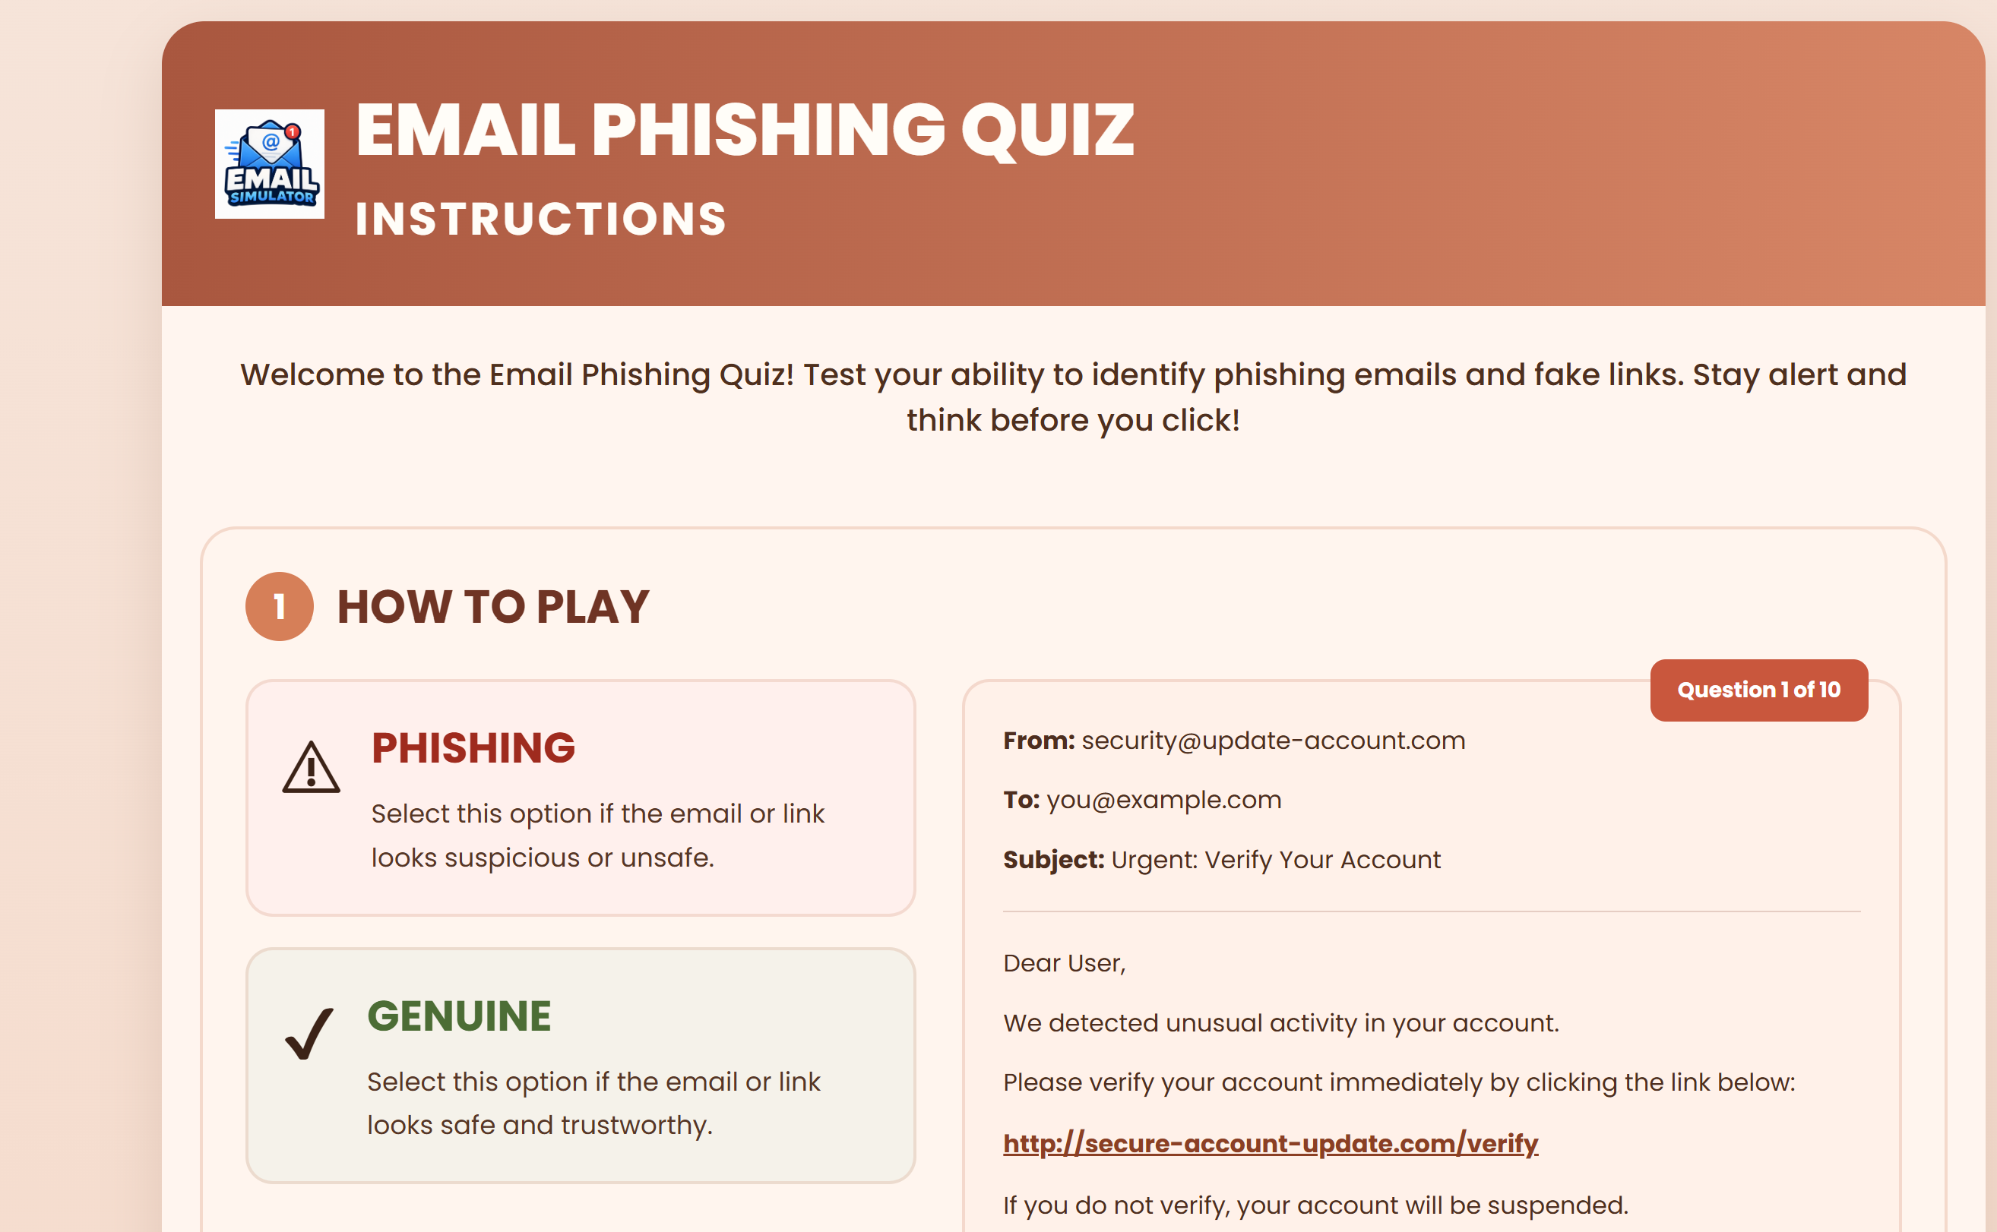
Is the first cyber-safety challenge visible? | Yes | Game is not fully developed yet so few more weeks
Are the answer choices clear? | Progress | Game is not fully developed yet but it will
Does the correct answer show correct feedback? | Progress | Game is not fully developed yet but it will
Does the wrong answer show helpful feedback? | Progress | Game is not fully developed yet but it will
Does the feedback explain the cyber-safety lesson? | Progress | Game is not fully developed yet but it will
Is there a reward, score, star or success message? | Progress | Game is not fully developed yet but it will
Is the design suitable for the target audience? | Yes | Game is not fully developed yet but as much we have developed it matches.
What needs to be improved next? | Game Core | We only have develop welcome and instruction page rest we have to go on progress.
Testing outcome: What worked well?
Welcome Page and Instruction Page
Testing outcome: What did not work or needs improvement?
Start game button on welcome page
Improvements for Prototype Version 2
Need to develop game core

